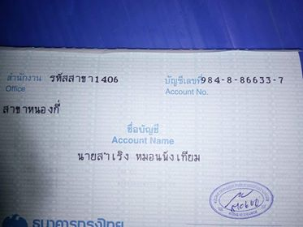
 | 11 Dec 2018 11:48 | Interbank Transfer  Recipient Account: KTB 9848866337 Account Name: MR.SAMROENG MONPHANGTHIAM; SAMRENG - SHOP SELLER Reference: Second payment of 50 000 for sho | 24,999.00 |  | 93,991.77 | IB
 | 10 Dec 2018 13:02 | Interbank Transfer  Recipient Account: KTB 9848866337 Account Name: MR.SAMROENG MONPHANGTHIAM; SAMRENG - SHOP SELLER Reference: Half payment of shop | 25,000.00 |  | 24,250.77 | IB
 | 10 Dec 2018 11:10 | Interbank Transfer  Recipient Account: KTB 9848866337 Account Name: MR.SAMROENG MONPHANGTHIAM; SAMRENG - SHOP SELLER Reference: Testing youir account. Papers?
