Daily Program
12 Nov. |  | Leave Norway
13 Nov. |  | Arrive Bangkok
14 Nov. |  | Arrival to Yangon, Burma. Market visits, colonial architecture and Shwedagon/Pagoda
15 Nov. |  | Yangon – Inle –Sea
16. Nov. |  | Boat Ride on Inle-Sea to Pælehus, floating gardens, markets and temples
17 Nov. |  | Inle Lake Heho–The Baga. Boarding
18 Nov. |  | The Baga. Time to Exploring the Temples
19. Nov. |  | The Baga to Salay and Tan-Chi-Taung-Mountains
20 Nov. | Pakokku. Tuk-Tuk-Tour and market visits
21 Nov. | Yandabo and Ava
22 Nov. | Saga, Amarapura and sunset at the U Bones Bridge
23 Nov. | Mingun and Mandalay
24 Nov. | Mandalay and Returning to Bangkok via Yangon.
25 Nov. | Arrive Bangkok

River Cruises in Burma
See similar Trips
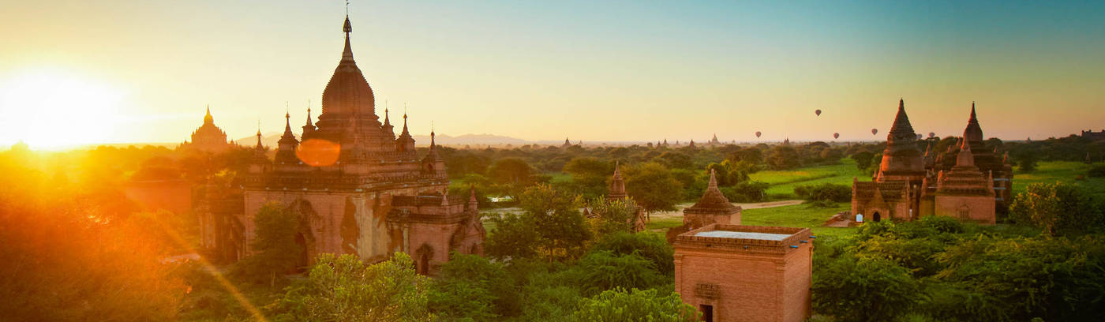
Group Travel With Albatros-Reiseleder
River Cruises in Burma Group Travel With Albatros-Reiseleder
- Introduction
- Pictures
- Departure dates
- Day Program
- Pricing Information
- Before Journey
Note Some of our travel is available in several editions. Remember to select the correct departure date before printing.
Go to order

Unique journey of discovery on the adventurous Irrawaddy River in the pristine Burma (Myanmar) with 7 day cruises and visits to Yangon and on Bagansletta
Departure dates
Leave | 13-11-2018
Duration | 13 days
Price | 29 998, –
Departure Airport | Oslo
Go To Order
Call us at21 98 45 45
Guest Reviews 4.8 | 21 Reviews»
Travel back in time, where adventure travel that on Kipling time still exists. In 7 days we sail on the country's lifeblood, the Irrawaddy River, on board the RV Katha Pandaw, where we are pampered in the most beautiful surroundings. Before we go aboard the ship, we reach both to see Yangon with the impressive Shwedagon-Pagoda and to experience the scenic Inle Lake .
The river leads us to areas of Burma which are only visited by few tourists. Thousands of temples, pagodas and stupas are strewn beyond the beautiful landscape and can be seen from the ship. In the country we visit sights and small villages far from the beaten path and get close to the hospitable population as we enter the markets and enjoy the Burmese cuisine. Southeast Asia's largest poi waiting for The Baga-Plain, where thousands of golden temple ceilings and spires adorn the landscape.
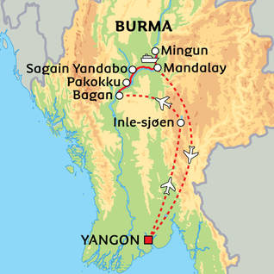
Click on the map to see it in large format
- Type Round tripCruise, , River Cruise, ,
- Tour leader Scandinavian Tour leader
- Visa Yes
- Vaccination Yes
- Currency Kyat, Euro, American Dollars
Day Program
Day 1 | Leave From Norway
Day 2 | Arrival to Yangon, Burma. Market visits, colonial architecture and Shwedagon/Pagoda
Day 3 | Yangon – Inle –Sea
Day 4 | Boat Ride On Inle-Sea to Pælehus, floating gardens, markets and temples
Day 5 | Inle Lake Heho–The Baga. Boarding
Day 6 | The Baga. Time to explore the temples
Day 7 | The Baga To Salay and Tan-Chi-Taung-Mountains

Day 8 | Pakokku. Tuk-Tuk-Tour and market visits
Day 9 | Yandabo and Ava
Day 10 | Saga, Amarapura and sunset at the U Bones Bridge
Day 11 | Mingun and Mandalay
Day 12 | Mandalay and Returning
Day 13 | Arrival To Oslo
Detailed Program

RV Katha Pandaw
The charming riverboat RV Katha Pandaw From Pandaw Cuises Combines old colonial style with modern comforts.
Both Is 40 meters long, was built in 2011 in Vietnam and sailed to Myanmar in 2012. The only 16 staterooms are distributed on the Main and Upper Deck. All are exterior with panoramic windows and have the output to the deck. There are two decks and lots of room to move around on. On Upper Deck There are 6 of the popular staterooms with lovely views from the deck. On Upper Deck is also the restaurant where the kitchen serves both Asian and European mad. On the sun deck, which is partly covered by a awning, you can enjoy the sun and the view from one of the comfortable sun loungers.
On the Main Deck There are 10 cabins. The ambience of the boat is relaxed and informal. There is no one Dresscode, nor in connection with dinners. Our tour leader provides lectures and shows film on board, as well as informing about the next day's excursions and activities.
The cabins are well furnished with en suite bathrooms and toilets, and have sliding doors out to the deck, so you can enjoy the view from both tires and from inside the cabin. There is also mini bar, air Condition, safe, hairdryer and bathrobe and slippers in your stateroom.
More about the ship
Click on the images to see them larger
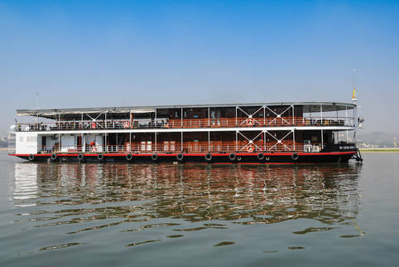
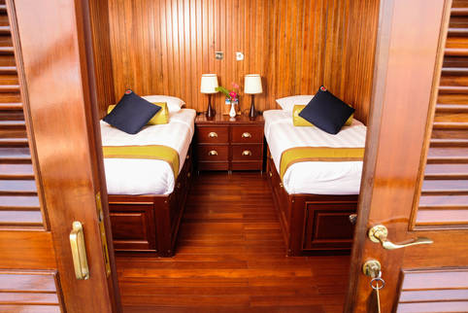
Day 1
Depart from Norway
Arrival to Yangon, Burma. Market visits, colonial architecture and Shwedagon/Pagoda
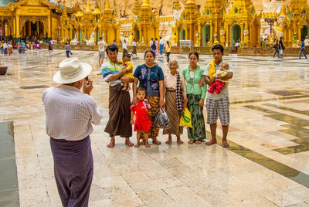
Shwedagon-Pagoda is Yangon's most famous edifice
We land in Burma's largest city, Yangon, in the morning. Yangon, who formerly named Rangoon, was the nation's capital from the British conquest of northern Burma in 1885 until 2005, where the entire state administration was moved to the city Nay Pyi Taw, almost 400 kilometers north of Yangon.
Although Yangon is no longer the nation's capital, it still remains the country's economic and intellectual center, and this tropical metropolis offers an exciting mix of modern city life, beautiful Buddhist pagodas and some of Southeast Asia's best preserved British colonial architecture.
On the way to the hotel we have a short photo jam at the royal Saraweik-The boat, which is a copy of an old kongebåt. At the hotel, it is possible to get a little rest before having lunch at a local restaurant. Then we go for a walk in Yangon's old quarter from colonial times. Many of the old buildings still remain intact, providing a unique insight into a time that was. We also put our way past the local Fruit Market And BogyokeMarket, also known as Scott Market, where one can find everything from antique Burmese handicrafts to precious stones, art galleries and local specialties. The market is named after James George Scott, a British official who spent many years of his life in the British Burma, and who introduced the population of football – today the country's most popular sport. When the country became independent in 1948, Scott Market was officially renamed Bogyoke Aung San.
Last in the afternoon we make the last halt to our excursion programme, by Yangons unconditionally most famous edifice: the breathtaking beautiful gold and Juvelbesatte Shwedagon-Pagoda, who thrones majestically on the Holy Hill Singuttara In the middle of the city. Anywhere in Yangon, you can always orient himself compared to the 98 metre high gilded Pagoda.
According to the legend, Shwedagon-Pagoda 2500 years old, while archaeologists estimate that it is built between the 500 and 900 century. Pagoda is the country's most important Buddhist sanctuary, with visits by many thousands of pilgrims each year, and it is said that it was built to protect eight hairs from the self-Buddha. At this time of the day there is a highly condensed atmosphere, and the Temple of Spirits of religiousity.
This time of day is the best place to visit. Here it is a wonderful atmosphere when believers and non-believers meet with local families during their picnics and still get the tourists. At this point, the light is also the most beautiful, and we see the sunset over Yangon from the temple area.
We round off the day with a welcome dinner at a local restaurant before we go to rest.
Accommodation in Yangon.
Day 3
YangonInle-Sea
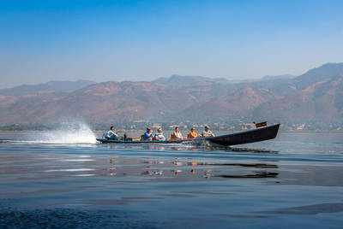
Welcome to Inle Lake!
Early in the morning we leave Yangon to fly to Heho, located one hour drive from the city Nyaungshwe On the Nordbredden of Inle Lake. From there, we rise on board a few smaller boats that take us out on the beautiful sea. We spend the next two days looking more closely at life in and around the sea, where fishing is still an important source of income. The local fishermen practice a very special Row stile, which is not so easy to copy: They stand in the boat and rudder with one leg twisted around the hearth. In this way, they have both hands free to lower the fish intoxication, and this closest to the acrobatic style is impressive to watch.
We are looking villages that stand out in the sea, and the floating gardens where they cultivate several forms of food plants, including tomatoes, cucumbers and eggplants. The traffic on the lake is a mixture of long-haul boats, which transports people, and farmers who are around their rowing boats to collect plants for their floating markets. We should also look Shandel-The state's most important holy pagoda, Phaung Daw Ow-Pagoda from the 1700 century. There will be five small Buddha statues that are transported each year around the Inle-The sea in connection with the sea's most important party. Over the years, pagoda has virtually evolved into a pilgrim shrine goal, and the five Buddha characters are so covered with gold leaf that they today almost lost their form.
We eat lunch at a local restaurant on the sea, and in the afternoon, we take a boat to our hotel, where we check in.
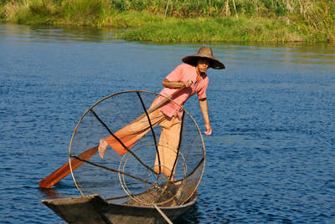
Fishermen very Special Style of rowing.
We have another day to enjoy the scenic surroundings. The 116 km² Sea Inlé Located at 900 meters altitude, so it may well be cold when we start in the morning (bring a hot sweater). Today's destination is the West Bank of the lake, where we visit Dein-Pagode complex, which is located well hidden and reached through a series of steps. It awaits us another impressive sight when we see how the stupas are virtually growing up out of the earth, and the whole area seems like it's gone into one with nature.
We visit one of the local markets that move around the area according to the weekday, and along the way we eat lunch at a local restaurant.
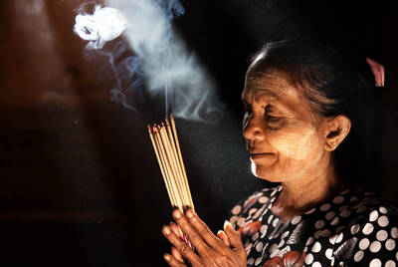
The Temples spirits of religiousity

After breakfast in the hotel we run the short road to the airport in Heho. From there, it takes less than an hour to fly to one of Southeast Asia's major sights, The Baga. The Baga is a 42 km² wide area that is home to over 3000 historic Buddhist temples. As far as the eye ranks, they pop distinctive, pointed temple towers up into the flat plain land closet, and it all has a tinge of mystery and unreal fairytale land cabinets over them. The start of the building of the First temple The Baga-Plain took place in 1057 after our time bill. King after King added more and more temples, until Kublai Khan's Mongolian troops 230 years later conquered the area.
On arrival at The Baga We accommodate on board the ship and enjoy a welcome drink and after lunch we go on a trip to Bagans Temple area. 4400 temples were built on the plain, and in spite of Nature’s Challenges such as earthquakes, floods, and erosion are comprised more than 3000 temples to this day. Site Kandiderer to get on Unesco List of World heritage, but a worst dispute between the authorities and the UNESCO on renovation methods have put the process on the break.
We see some of The Baga-plain’s most significant pagodas, including AnandaTemple, a whitewashed masterpiece combining Mon architecture with Indian architecture. According to a legend, king Kyanzittha Killed the eight monks who built the temple, so that they could not build a similar temple anywhere else.
Day 6
The Baga. Time to explore the temples
We have another day to explore the many temples in the area while our ship is located here.
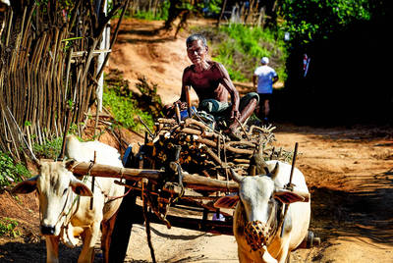
Everyday life in Burma
Early morning, we leave The Baga by boat to Salay. The town was once a busy seaport, but is today a sleepy fishing village. It offers ancient buildings in colonial style, but most impressive are the many monasteries built in Teaktre.
We continue the tour up the river and arrive during the afternoon to the foot of Tan-Chi-Taung Mountains. Here we replace the ship with small minivans and drive up to enjoy the view of the breathtaking landscape.
We end the day by visiting a local clinic/doctor's practice supported by the cruise line Pandaw and their guests. Pakokku. Tuk-Tuk-Tour and market visits

We visit different local markets
After another delicious breakfast on the ship, we jump aboard a Tuk-Tuk (A kind of Wooden Wheel Motorbike taxi), which takes us through Pakokkus Bustling streets. We put our way past the city markets and look at all sorts of merchandise sold and bought here.
We continue the journey up the Irrawaddy River and reach the point where another of the country's large rivers, Chindwin-The river runs into the Irrawaddy River. Here Add We To For Night.
Day 9
Yandabo and Ava
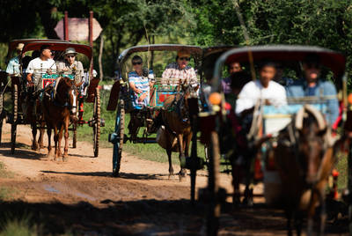
On tour of Ava In horse carts
Today we come to Yandabo, a picturesque village famous for its production of ceramics. The village is also interesting from a historical perspective, for it was here the peace treaty between the British and the Burmese was signed in February 1826 after the first Anglo-Burmese War. We visit some of the local workshops and see how the clay goods are becoming.
In the afternoon we reach the old capital Ava, which was the country's capital from 1365 to 1842. The city is well strategically located on an island between Irrawaddy and Myitnge River. If time permits, take a tour of the Ava In horse-carts and watching Bargayar-The abbey, where the royal Burmese received their education. The abbey is richly adorned with Three shacks.and sunset at the U Bones Bridge
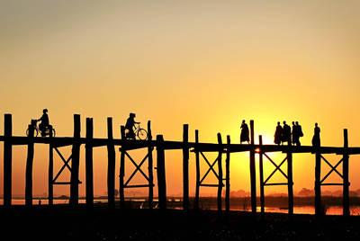
Beautiful sunset by the famous bridge U bones
We drive by bus through the rugged landscape of Saga, who after Bagans Fall was the capital in a fairly short period. There is a beautiful view from Åstoppene Of the landscape and the Irrawaddy River. Before returning to the ship and eating lunch, we visit a silver workshop and Sun-U-Ponnya-Shin-Pagoda from the 1300 century.
We continue to Amarapura ("the Immortal City "), which for a period of 50 years (1783 – 1833), was the country's capital. Here we visit the famous 1.2 kilometre-long U Bone Bridge, the world's longest footbridge in Teaktre. It rests on over a thousand bridge pillars over Taungthaman-The sea and connects Taungthaman-The island with the mainland. Although the U Bone Bridge is more than 200 years old, it is still in nice condition. It is one of Burma's most photographed sights, and there is often a life of local inhabitants who walk or cycle over the bridge.
Dinner, we're enjoying the ship.
Day 11
Mingun and Mandalay
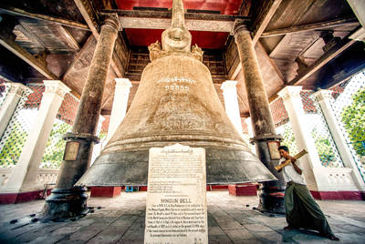
Mingun-The clock weighs about 90 tonnes
Today the last part of our odyssey awaits in Burma's most important and longest river, Irrawaddy. Today's first stop is Mingun, where we will see Mingun-One of the heaviest clocks in the world around 90 tonnes. I Mingun We also look closer at the white Hsinbyume-Pagoda, with a white color that symbolizes the Buddhist mythological mountain Meru.
Back on the ship, we continue our journey up the river while we eat lunch on board.
Later, when we end our destination, Mandalay. With an impressive number of Buddhist pagodas – more than 700 – and a large number of monasteries are Mandalay Burma's absolute religious centre. Of the country's 500 000 Buddhist monks live approximately 60 percent in Mandalay and live a life of asceticism from centuries-old principles and rituals. Mandalay is also known for its rich arts and crafts traditions. During the Burmese kingdom, if the last main seat was here in Mandalay, many of the local artists and Kunsthåndverkerne suppliers were to the court, and the proud, creative traditions comprised it today.
In the afternoon we visit first the famous MahamuniPagoda. In the midst of the pagodens condensed atmosphere, there is a Buddha figure that through several hundred years has been glued to the gold leaf. As a fun kuriosum, it can be noted that the Buddha figure every morning gets brushed teeth and purified nails of the temple's monks. In the area we are also looking at how gold gets knocked out to gold leaf.
Then we see the small but incredibly beautiful ShewendawMonastery, which is made up of neatly and detailed carved teaktre. Originally, the building was gilded both outside and inside, but time has left its tracks, and it is now only inside that light can give glare to the golden surfaces.
We drive back to the ship and enjoy our last dinner on board.
Day 12
Mandalay and Home Travel
It's been time to leave the ship, and after breakfast we check out from the ship and drive to the airport in Mandalay. From there we fly back to Yangon. We have a few hours to go on a discovery trip in Yangon before we fly home. In Yangon we eat a farewell dinner together, and it will be possible to take a bath and change clothes before we set ourselves right in the airplane.
Day 13
Arrival in Oslo

Https://www.momondo.com/flight-search/OSL-RGN/2018-11-11/RGN-BKK/2018-11-26/BKK-OSL/2018-11-30?sort=price_a

