http://www.crazykims.vn/grammar.htm
Martin’s 16 basic (elementary) grammar lessons of 297.

- A noun names a person, place, thing, or idea. A naming word. Grammar summary
- Count noun, a noun that can form a plural. Count nouns
- Possessive nouns are used to indicate ownership. Possessive nouns
- Pronoun takes the place of a noun. Pronoun song
- 'Be' Verbs. A verb a state of being.

- Action verbs, also called dynamic verbs, express an action, whether it be physical or mental.
- Adjectives describe or modify noun.
- Comparative and Superlative Adjectives.
- Adverbs modify a verb, an adjective, or another adverb.
- Tense of a verb tells you when the action happens.
- Progressive Tense, involves action that is, was, or will be in progress.
- Perfect continuous tense shows that something started in the past and is continuing at the present time.
- Prepositions "On," "At," and "In” links a noun, pronoun, or noun phrase..
- Prepositions "Of," "To," and "For" links a noun, pronoun, or noun.
- Prepositions
- 24A: Prepositions’ recap.

Never say nothing, if you don’t know, say so. Never answer with one word but with a subject and verb using intransitive verbs, and an object if you have a transitive verb.

A subject does something to the object.
Một chủ đề làm một cái gì đó cho đối tượng.
A verb tells what the subject wants to do.
Một động từ cho biết những gì chủ đề muốn làm.
An object is what the subject will do something to or with.
Một đối tượng mà đối tượng sẽ làm một cái gì đó để hoặc với.

Only transitive verbs take an object like kick and throw. Kick what?
Intransitive (stative) verbs do not take an object like agree, appear, arrive, happen, leave, lie, listen, panic, smile, talk, work, and yell.

Why do we learn? Because we want to.
How much do you want to learn (motivated are you) on a scale from 1 – 10?

Grammar04: Pronoun takes the place of a noun. The Noun Song.
Đại từ Một đại từ thay thế cho một danh từ
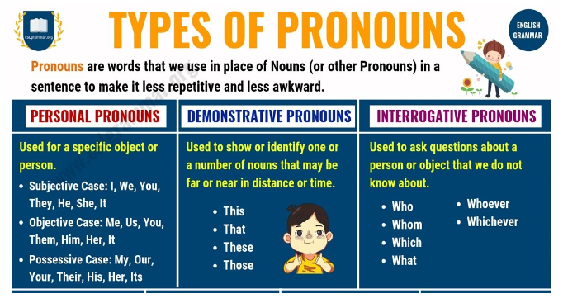

Why do we use pronouns?

We often use pronouns to avoid having to repeat the same noun repeatedly.
Pronoun
is a word that can function by itself as a noun phrase and that refers either to the participants in the discourse (for example, I, you) or to someone or something mentioned elsewhere in the text (for example she, it, this ).

This makes our language shorter and less repetitive.

Example story:

Mary is one of the heads of the ToJi Corporation.

Mary works with Mr. James and Mr. James' son Tom.

Mr. James and Mr. James' son Tom are experts in biochemistry (hóa sinh).

Mary, Mr. James, and Tom researched and invented a drug for cancer treatment.

Translation:

If the story above is written using pronouns:

Mary is one of the heads of the ToJi Corporation.

She works with Mr. James and his son Tom.

He and his son Tom are experts in biochemistry.

They researched and invented a drug for cancer treatment.

Personal Pronouns
Personal pronouns refer to a person:
- I go to school.
- You are a student.
- They are Koreans. The plural of ‘Vietnamese’ is ‘Vietnamese’. Only use 'the” if you are speaking about a specific group of Vietnamese people.
- He works here.
- We gave her food.
The word 'it' refers to an object:
- I drank it.
- It is big.
- They cut it into halves.

Homework:
Memorize (Ghi nhớ) the personal pronouns:
 | First  person | Second  person | Third  person
 |  |  | Male | Female | Neutral
Singular Subject (Môn học số ít) | I | you | he | she | it
Singular Object (Đối tượng số ít,) | me | you | him | her | it
Singular Reflexive (Phản xạ số ít,) | myself | yourself | himself | herself | itself
Plural Subject (Chủ ngữ số nhiều) | we | you | they
Plural Object (Đối tượng số nhiều) | us | you | them
Plural Reflexive(Phản xạ số nhiều) | ourselves | yourselves | themselves

Pronoun takes the place of a noun, long one with Ganesh and a special one,
Who, Whom and Whose with Ganesh.

Quiz 4.1
Quiz 4.2
Pronouns for Kid
Quiz 4.2 -https://www.englishclub.com/grammar/pronouns-quiz.htm online

[Quiz 4.1] – 15 questions
Write the correct pronoun in each blank.

1) I ate an apple. _____was delicious.
2) You look tired. _____should rest.
3) She is a teacher. I gave _____a book.
4) They are my friends. I like_____very much.
5) He saw the movie. _____was fun.

- _____ one of you jokers filled my pillowcase with shaving cream?
- ______ many of us are going?
- Keeping Annika’s yard clean was a difficult job for _____.
- ______ did not want to get wet in the rain, so the students ate lunch in the gym.
- Yen keeps roses in her backpack because she does not want to lose _____.
- Lola the cat is very fond of ____ (Alice, food, me)
- Glory gave ____ a big hug. (Darcy, the tree, her)
- ______ is the best chef in Nha Trang. (Ha, he, the man)
- All the cookies belong to ______. (Us, Duy, the boys)
- The pig escaped before anyone could stop ______. (The pig, it, it's)

Answers:  1) it  2) you  3) her  4) them  5) it | - Which one of you jokers filled my pillowcase with shaving cream.  - How many of us are going?  - Keeping Annika’s yard clean was a difficult job for her.  - They didn’t want to get wet in the rain, so the students ate lunch in the gym.  - Yen keeps roses in her backpack because she does not want to lose them.  - Lola the cat is very fond of ____ (Alice, food, me)  - Glory gave ____ a big hug. (Darcy, the tree, her)  - ______ is the best chef in Nha Trang. (Ha, he, the man)  - All the cookies belong to ______. (Us, Duy, the boys)  - The pig escaped before anyone could stop ______. (The pig, it, it's)

Test 4.2
Reciprocal pronouns
There are only two reciprocal pronouns. Both allow you to make sentences simpler. They are especially useful when you need to express the same general idea more than once.
- Each other
- One another

Reciprocal pronouns are easy to use. When you want to refer to two people, you will normally use “each other.” When referring to more than two people, for example the students in a lecture hall, you will normally use “one another.”

Translation:

Choose one answer.
1. Pronouns take the place of a noun, a verb, an adjective
2. What do pronouns help us add to our speech and writing? personality, variety, detail
3. What sort of pronouns are the words "he", "me" and "you"? interrogative, possessive, personal
4. What sort of pronoun is the word "we"? singular, subject, object
5. Which personal pronoun is almost always used for a thing? he, it, they

6. To refer to something that is far from you, use the pronoun this, that, these
7. "This is Lisa speaking." In this sentence, what sort of the pronoun is the word "This"?
reciprocal, demonstrative, personal
8. Possessive pronouns can be subject pronouns or object, interrogative, or indefinite pronouns,
9. With a singular pronoun the verb should be singular, plural, singular or plural
10. What sort of pronoun are the words "each other" and "one another"? interrogative, reciprocal, indefinite,

Correct or Incorrect. (C / IC)
- The boss gave the project to Corey and me. _______
- I and Paige work together. _______
- Paige and I work together. _______
- Me and Paige work together. _______
- Paige and me work together. _______

Test 4.2 – Answers:
1. Pronouns take the place of a noun
2. What do pronouns help us add to our speech and writing? variety
3. What sort of pronouns are the words "he", "me" and "you"? personal
4. What sort of pronoun is the word "we"? subject
5. Which personal pronoun is almost always used for a thing? it

6. To refer to something that is far from you, use the pronoun that
7. "This is Lisa speaking." In this sentence, what sort of the pronoun is "This"? demonstrative
8. Possessive pronouns can be subject pronouns or object pronouns
9. With a singular pronoun the verb should be singular
10. What sort of pronoun are the words "each other" and "one another"?
reciprocal
Correct or Incorrect. (C / IC)
- The boss gave the project to Corey and me. C
- I and Paige work together. IC
- Paige and I work together. C
- Me and Paige work together. IC
- Paige and me work together. IC

